Collaborative Practice Agreement
Diabetes Management
{PHARMACY/INSTITUTION NAME}

Collaborative Practice Agreements (CPAs) are used to create formal relationships between pharmacists and physicians that allow for expanded patient care services the pharmacist can provide to patients and the healthcare team.

The authority to obtain patient history, collaborate on physical assessments, order and assess diagnostic tests, make medication related medical decisions, and modify therapy management options is derived from the delegation of that authority by the Wisconsin licensed physicians signed below, in accordance with Wisconsin Act 294, Pharmacy Chapter 450.033, which reads

450.033 Services delegated by physician. A pharmacist may perform any patient care service delegated to the pharmacist by a physician, as defined in s. 448.01 (5).

The Wisconsin licensed physician(s) signed below are working in collaboration with the following clinical pharmacists, licensed in Wisconsin, and agree to delegate and supervise delegated medical acts as defined in the attached Scope of Pharmacy Practice Guidelines and Treatment Protocols.

(Name, MD/DO, WI License #, Date) |  | (Name, PharmD, WI License #, Date)
(Name, MD/DO, WI License #, Date) |  | (Name, PharmD, WI License #, Date)
(Name, MD/DO, WI License #, Date) |  | (Name, PharmD, WI License #, Date)
(Name, MD/DO, WI License #, Date) |  | (Name, PharmD, WI License #, Date)
(Name, MD/DO, WI License #, Date) |  | (Name, PharmD, WI License #, Date)

Scope of Pharmacy Practice Guidelines

Purpose

The goal of this agreement is to improve care, achieve optimal outcomes, and provide continuity of care to patients through the provision of pharmacy patient care services, which include therapy care plan development, medication management, education, monitoring, and follow-up, as it relates to diabetes management in adults.

Organization

Guidelines for referral
Any patients who have an MD or DO working at {PRACTICE LOCATION} listed as their Primary Care Provider (PCP) in {EHR}, whose PCP has signed this agreement may be referred for diabetes management by the pharmacist. An MD or DO may also refer a specific patient for pharmacist services through documentation in the patient’s chart in {EHR}.

For pharmacist-identified patients who have not had an office visit with PCP in over 1 year and does not have an office visit scheduled in the next 6 months, the pharmacist will offer an appointment to the patient for an office visit with PCP.

Patient care services provided by the pharmacist include, but are not limited to,
- Obtain patient medical history
- Order and evaluate laboratory results
- Make medical decisions including initiating, modifying, or discontinuing treatment
- Refill authorization
- Provide patient counseling on medications and lifestyle modification, including diet and exercise
- Referral to appropriate providers (i.e. diabetes educator, care management, etc.)

Documentation
All patient encounters will be documented in the patient record and will be available to the supervising physician for review.

Quality Improvement

Data will be continuously monitored to ensure that patients are receiving optimal care. Clinical activities will be reviewed periodically by the clinical pharmacist and physician providers and revised as needed. This CPA will be valid for 2 years from the date it is signed and must be reviewed and resigned by all parties after 2 years to remain effective.

Modifications
Any modifications to this agreement must be dated and signed by all collaborative partners.
Treatment Protocol

The clinical pharmacist will apply nationally recognized evidence-based treatment guidelines, as well as up to date clinical research information when providing diabetes management services. The following treatment guideline(s) and resources will be utilized to help direct the treatment of patients.

  - 2020 American Diabetes Association Standards of Medical Care in Diabetes
  - 2020 Consensus Statement by the Association of Clinical Endocrinologists and American College of Endocrinology on the Comprehensive Type 2 Diabetes Management Algorithm

From those guidelines, the pharmacist will use the following guiding principles for management of diabetes mellitus. These principles are not binding, and the pharmacist may deviate from what is outlined below based on an individual patient’s clinical situation. If deviations are made, the pharmacist will document rationale in the patient chart.

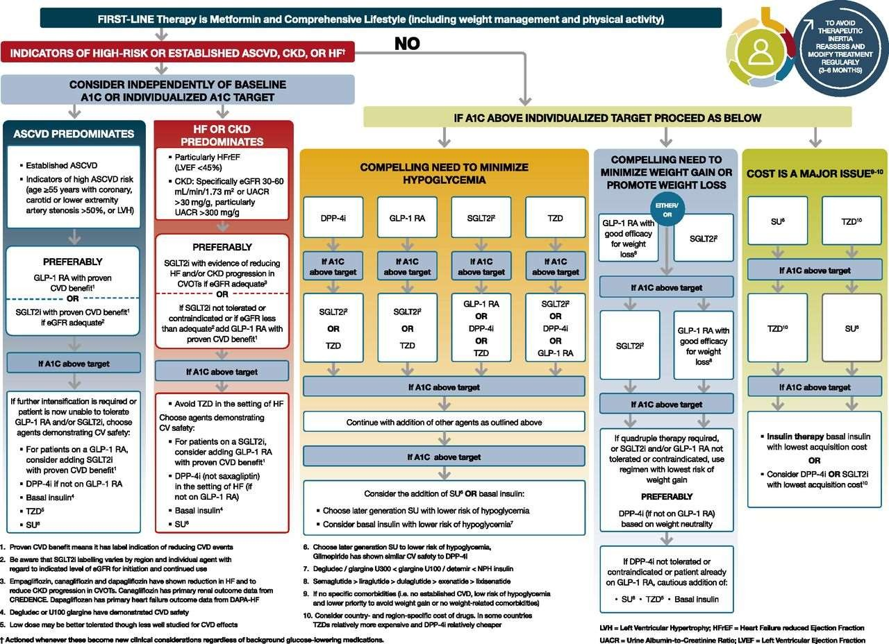

American Diabetes Association. 9. Pharmacologic Approaches to Glycemic Treatment: Standards of Medical Care in Diabetes-2020. Diabetes Care. 2020;43(Suppl 1):S98–S110. doi:10.2337/dc20-S009

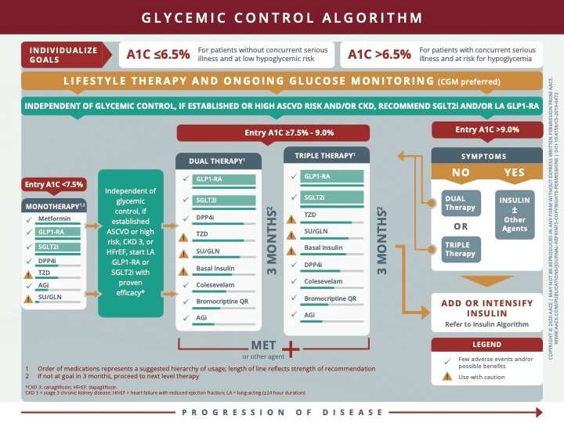
Garber AJ et al. Consensus Statement by the Association of Clinical Endocrinologists and American College of Endocrinology on the Comprehensive Type 2 Diabetes Management Algorithm – 2020 Executive Summary. Endocr Pract. Jan;26(1):107-139. doi 10.4158/CS-2019-0472

Lifestyle/Diet Modification
- May not be enough alone
- Referral to dietician/diabetes educator as appropriate
- Recommended diabetes education annually
- Cost may limit patients’ ability/willingness to participate in these services

First-line Pharmacologic Treatment – Metformin
- XR formulation may decrease adverse gastrointestinal side effects
- Recommended starting dose = 500 mg daily (XR or IR)
- Increase dose every 1-2 weeks to further limit adverse GI effects
- Max effective dose = 2,000 mg daily (XR or IR)
- Emerging evidence shows safe use with decreased dose and monitoring down to eGFR of 30 mL/min
- Okay to initiate if eGFR greater than 45 mL/min
If Not at Goal A1c Within 3 Months of Therapy
- Add-on additional agent
- Second-line – in order of clinical pharmacist preference, in absence of contraindication/precaution or cost concerns, based on appropriateness for when hyperglycemia is occurring, and taking into consideration co-morbid conditions, as outlined in the ADA 2020 Standards of Medical Care in Diabetes and 2019 AACE/ACE Comprehensive Type 2 Diabetes Management Algorithm
  - GLP-1 agonist
  - SGLT-2 inhibitor
  - Basal insulin
  - Sulfonylurea
  - Thiazolidinedione
  - DPP-IV inhibitor
- Other available agents
- If uncontrolled on combination of 3 oral/injectable medications – basal/bolus or 70/30 insulin

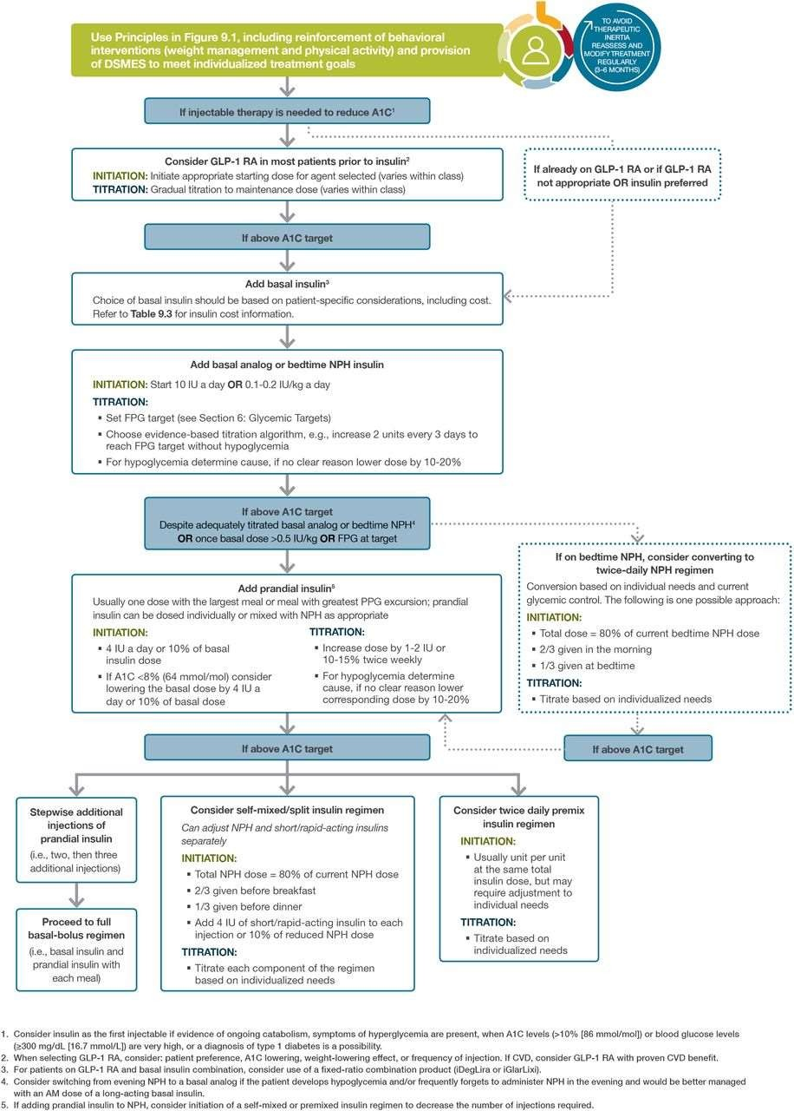

General Monitoring
- A1c
  - Every 6 months, if at goal
  - Every 3 months, if not at goal
  - Additional testing PRN
- Microalbumin
  - At diagnosis
  - Annually, if no evidence of proteinuria
  - Guidelines are less clear once proteinuria is established and treated with ACE-I or ARB
  - Initiate ACE-I/ARB when urine albumin:creatinine > 30 on 2 of 3 tests in a 3-6 month period
- Annual diabetic eye exam
- Daily self-administered foot exam
- Self-monitoring of blood glucose

Drug-Specific Monitoring

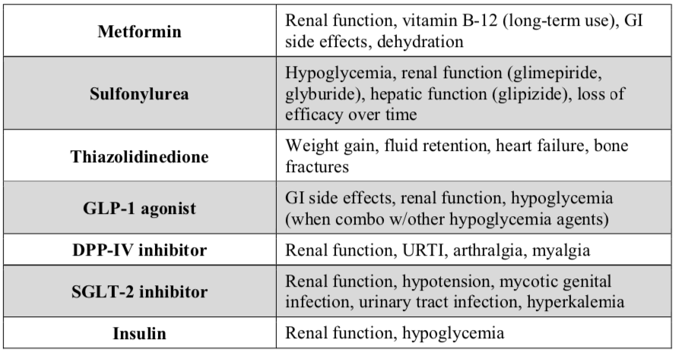

Disclaimer: This Collaborative Practice Agreement (CPA) Diabetes Management example template is intended to assist pharmacists in the development of a CPA for management of diabetes with a corresponding physician(s). This information is not intended to be a substitute for professional training and judgment. It is always best to consult additional references to confirm doses. Use of this information indicates acknowledgement that neither PSW nor its contributing authors will be responsible for any loss or injury, including death, sustained in connection with or as a result of using this information. PSW is under no obligation to update the information contained herein.

